Mid Semester Examination (Winter 2023)
Branch: 5th Sem, B.Tech. CSE Course: Operating Systems (CSL309)
Duration: 1.5 hours Max. Marks: 25

Q1. What is the purpose of a trap table in an operating system? What does it contain? When is it consulted? When is it loaded? Answer concisely. [2m]

Q2. Context switching between two threads of execution within the operating system is usually performed by a small assembly language function. In general terms, what does this small function do internally? [2m]

Q3. Consider the following code and answer the questions:
int main(void) {
pid_t pid = -1;
for(int i=0; i<4; i++){
pid = fork();
if(pid != 0){
break;
}
}
waitpid(pid, NULL, 0);
printf(" %d, %d, %d \n", getpid(), pid, &pid);
return 0;
}
- Draw the shape (illustration) of process hierarchy that this code produces clearly indicating different processes and their relationship by appropriate name/IDs. [2m]
- What are the values printed by each process? Will they be same or different? [1m]
- Will the order of printing be consistent or arbitrary? Why? [1m]

Q4. Given a 3-level MLFQ scheduler with a quantum length of 2 ms, 4ms, 6ms in its highest, middle and lowest queue respectively.
a) How often would you have to boost jobs back to the highest priority level to guarantee that a single long-running (and potentially starving) job gets at least 20% of the CPU, assuming there are not too many processes competing for CPU? [1.5m]
b) Let say the priority boost happen every 8 ms and 3 jobs arrive together in the order A, B & C with job length of 6, 20 and 10 respectively. When the priority boost fires, the current job is pre-empted and the next scheduled job is run in round-robin order. Draw the scheduling in the below graph (as discussed in class) showing the vertical lines for key events and clearly labelling the X-axis times. [3m]
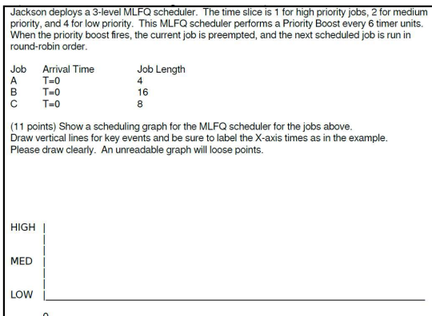

Q5. a) What does TLB miss handler do when TLB miss occurs during an address translation. Explain your answer based on the valid and present bits of the page table entry. [1.5m]
b) Consider a paging system that uses a one-level page table residing in main memory and a TLB for address translation. Each main memory access takes 100 ns and TLB lookup takes 20 ns. Each page transfer to/from the disk takes 5000 ns. Assume that the TLB hit ratio is 90%, page fault rate is 10%. Assume TLB update time and page table entry update is negligible. What is the average memory access time (in ns) ? [2m]

Q6. A certain computer system uses segmented paging architecture for memory virtualization. The memory is byte addressable. Both virtual and physical address spaces contain 64K bytes each. The virtual address space is divided into 8 non-overlapping equal size segments. The memory management unit (MMU) has a hardware segment table, each entry of which contains the physical address of the page table for the segment. Page tables are stored in the main memory and consist of 2 byte page table entries. What is the minimum page size in bytes so that the page table for a segment requires at most one page to store it? Show suitable calculations. [3m]

Q7. Consider an OS using a two-level page table. Assume a 32-bit virtual address space, 4 KB pages, page table entry (PTE) is 4 bytes in size. Answer the following questions [2+2 = 4m]
  - What is the minimum number of valid virtual pages in an address space such that the multi-level page table becomes its maximum size? Explain.
  - What is the minimum number of pages needed for the multi-level page table (including the page directory) when there are 1025 contiguous valid pages somewhere in the virtual address space? Explain.

Q8. Consider a main memory with five page frames and the following sequence of page references: 3, 8, 2, 3, 9, 1, 6, 3, 8, 9, 3, 6, 2, 1, 3. Assuming all frames are empty initially, find the number of page faults using Least Recently Used (LRU) page replacement policies? Show suitable calculations [2m]

--------------xxx-----------------

Course Outcomes:
At the end of the course the students will be able to:

CO1: Demonstrate understanding of CPU and Memory virtualization and implement related concepts.
CO2: Demonstrate understanding of concurrency issues and implement solutions to related problems
CO3: Demonstrate knowledge and understanding of how operating systems manages persistent data storage.

Mapping of Course Outcomes to Program outcomes:

 | PO1 | PO2 | PO3 | PO4 | PO5 | PO6 | PO7 | PO8 | PO9 | PO10 | PO11 | PO12
CO1 | Strong | Medium |  |  |  |  | Medium | Medium |  | Weak
CO2 | Strong | Medium |  |  |  |  | Medium | Medium |  | Weak | Weak
CO3 | Strong | Medium |  |  |  |  | Medium | Medium

Question Paper to CO mapping:

Sessional 1 |  |  |  | Sessional 2 |  |  |  | End Semester
Q.No. | CO-1 | CO-2 | CO-3 | Q.No. | CO-1 | CO-2 | CO-3 | Q.No. | CO-1 | CO-2 | CO-3
1 | √ |  |  | 1 |  | √ |  | 1
2 | √ |  |  | 2 | √ |  |  | 2
3 | √ |  |  | 3 | √ |  |  | 3
4 | √ |  |  | 4 | √ |  |  | 4
 |  |  |  |  |  |  |  | 5
 |  |  |  |  |  |  |  | 6
 |  |  |  |  |  |  |  | 7
 |  |  |  |  |  |  |  | 8
 |  |  |  |  |  |  |  | 9
 |  |  |  |  |  |  |  | 10

Assessment of Attainment of Course Outcomes:
 | First Sessional  (15) | Second Sessional  (15) | End Term  (50) | Lab & assignments
CO1 | 100%
CO2
CO3

